**Phase 2: Business Process Modeling**

**1. Define Scope**

* **Scope Example**: The project aims to create a streamlined, digitalized process for applicants to obtain driving licenses. This process will support tasks from initial registration through examination and result notification.
* **Objectives**:
  + Minimize manual data handling to reduce errors.
  + Automate notifications (like exam schedules and results).
* **Expected Outcomes**:
  + Improved data accuracy and faster processing times.
  + A centralized database accessible by authorized departments.

**2. Identify Key Entities**

* **Entities**:
  + **Applicant**: Individual applying for the driving license.
  + **Police Officer**: Approves applications and validates documents.
  + **Examination center**: Conducts the driving exam and logs results.
  + **License**: successful licensed
* **Interactions**:

Examiners evaluate driving exams, police officers verify, and applicants submit applications. The MIS records the results and sends out notifications.

**3. Logical Flow**

* **Flow**: Start from **Application Submission** → **Document Verification** → **Exam Scheduling** → **Exam Result Recording** → **License Issuance or Retest Notification**.
* **Decision Points**: These are added in situations like "Document Approved?" and "Exam Passed?"

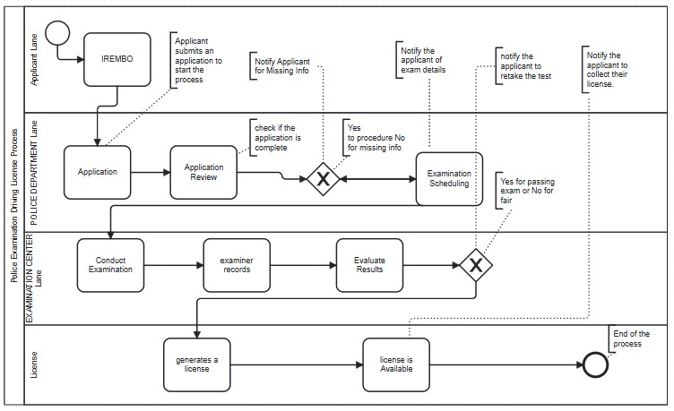

**4. Explanation**

* “The applicant submits the required paperwork to start the driving license examination process, and the police department checks it to make sure it meets the requirements for acceptance. An automated notification system notifies applicants of the exam date, which is automatically arranged. The license issuance procedure is started when the test results are entered straight into the system. Since the entire process is centralized in a Management Information System (MIS), the police department can make decisions more easily, operate more efficiently, and reduce manual errors.”

**Phase 3: Logical Model Design**

* + 1. **Design the Data Model**

**• Entities & Attributes:**

* Applicant: applicant_id (PK), fname,lname,Date_birth,gender,address.
* Application:applicationid(FK),applicantid(Fk),Application_date,status,remarks.
* Examanition_schedule:scheduledid(PK), applicationid(FK),examdate,examcenterid(Fk),notificationstatus.
* Examinationcenter_id (PK), centername, location, capacity.
* Test:Testid(PK),schedulerid(FK),examinerid(FK),testType,result,comments.
* Examiner:Examinerid(PK),fname,lname,qualification,assignedcenter.
* License:licenseid(PK),applicantid(FK),issuedate,expirationdate,Licensetype
* Notification: notification_id (PK), scheduler_id(FK), sentdate,status,messagetype.

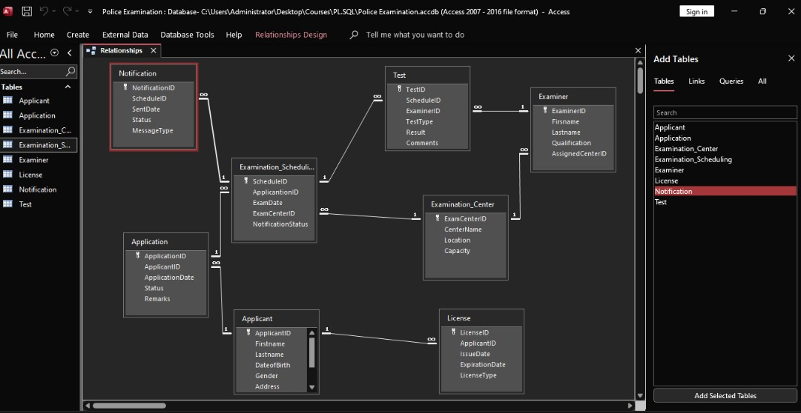

**• Relationships:**

o One-to-Many: One applicant can have multiple exam attempts.

o One-to-One: One result per exam.

* + 1. **Handle Data Scenarios**

• **Scenario 1:** Failed Exam - Track the count of failed attempts; add a retest_allowed flag.

• **Scenario 2:** License Issuance - If an applicant passes, issue a license and archive the record.

• **Scenario 3:** Notifications - Trigger notifications for exam dates and results.